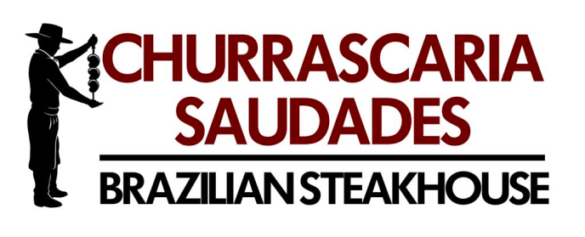

Saudades Group, LLC
1232 Choptank Road
Middletown DE 19709
302-832-0673

<<Addressee>>

December 19, 2016

Dear Mr <<>>,

<<Body of letter>>

Sincerely,

Michael A. Jackson
General Manager

